

**Will be holding joint COVID Vaccination clinics at The Steam Museum, Fire Fly Avenue, SN2 2EY.**

**Brunel Health Surgeries include:**

* **Ashington House Surgery**
* **Carfax Medical Practice**
* **Eldene Surgery**
* **Elm Tree Surgery**
* **Great Western Surgery.**
* **Kingswood Surgery**
* **North Swindon Practice**
* **Park Lane Surgery**
* **Phoenix Surgery**
* **Ridge Green Medical Centre: Freshbrook Surgery, Ridge Green Surgery**
* **Ridgeway View Family Practice**
* **Sparcells Surgery**
* **Victoria Cross Surgery, Eldene Health Centre**
* **Westrop Medical Practice: Highworth, Hermitage, Blunsdon, Taw Hill**

**CORONAVIRUS Vaccine**

A Coronavirus (COVID-19) vaccine developed by Pfizer/BioNTech has been approved for use in the UK.

This vaccine will begin to be made available from this week. The vaccine has met the strict standards of safety, quality and effectiveness set out by the independent Medicines and Healthcare products Regulatory Agency (MHRA).

Although other vaccines are being developed they will only be available once they have been thoroughly tested to make sure they are safe and effective.

**Vaccine Safety**

Any vaccine including the coronavirus vaccine must go through all clinical trials and safety checks and all other licensing medicines go through. The UK has some of the highest safety standards in the world.

Vaccines will only be used if they are approved by the MHRA. The MHRA has been monitoring every stage of the coronavirus vaccine development.

**Who will get the vaccine?**

We will contact all patients when they become eligible for the coronavirus vaccine.

**Our clinics will be held at the STEAM Museum. This will be for patients from the surgeries who are part of the Brunel Health Group.**

**Information for Patients**

We will be contacting patients to book two appointments (which will be three weeks apart - it is essential that you attend both appointments). The vaccination centre will be based at Steam Museum in the centre of Swindon (see directions below). Please ensure that you arrive for both appointments at your allocated time so we can ensure social distancing measures are in place. If you can, please come on your own, or with one other person if you require support.

We are asking all patients to wear a face covering. This is to protect you and others around you. We are also asking patients to wear loose fit clothing that is easy to remove so that we are able to see you in a timely manner. Please do dress in warm clothing, as there may be a queue although this should be fast moving as we have several clinicians that are working in the building.

Fire Fly Avenue

Car parking

The Steam Museum

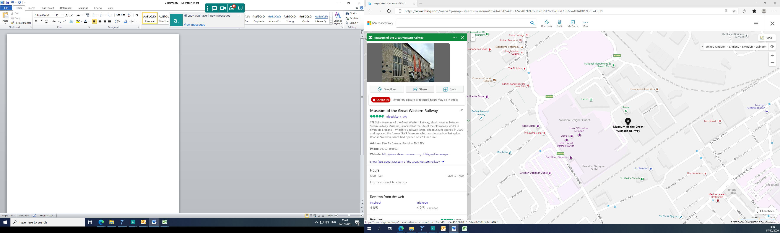

Blue Badge holder car parking